W2 ANALYSIS

*MOBILE* ***UI COMPONENTS***

* You have already drawn a **user flow** for the app BlaBlaCar, for the bellow **use case**:

As a user I can to check the list of rides

-From Rennes to Paris, next week on Sunday

-I want only ride accepting pets

* Now you will identifythe **UI components** used to guarantee a great UX on this use case
* You will **evaluate** those UI components based on well-defined **heuristics** and **criteria**



*BlaBlaCar Car Application*

## *How to start?*



* Install BlaBlaCar ([Google play](https://play.google.com/store/search?q=blablar%20car&c=apps&hl=en) or ([Apple store](https://apps.apple.com/us/app/blablacar-carpooling-and-bus/id341329033)) on your computer
  + You can use an Android emulator connected to internet
  + You can also use [Blue Stack](https://www.bluestacks.com/) to install this app



*Run mobile app on your desktop with Blue Stacks*

**VIEW 1** – Select Ride Inputs

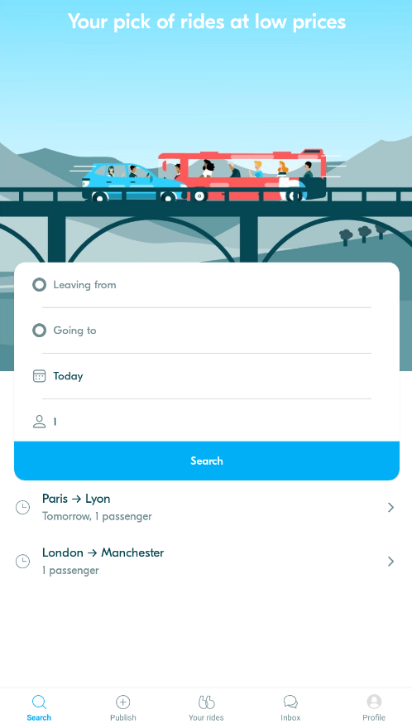

**Q1 –** What are the different **workflows** to select ride inputs (*from / to /date / passenger*)?

* **Workflow 1:** Click on "From" field > Select location > Click on "To" field > Select location > Click on "Date" > Pick date > Click on "Passengers" > Select number > Click "Search" to proceed.
* **Workflow 2**: Click on "Plan Your Ride" > Select "From" location > Select "To" location > Choose date > Select number of passengers > Click "Search" to proceed.

**Q2 –** What are the **used UI components** and your **UX analysis** for each of bellow scenario: (see example)

|  |  |  |
| --- | --- | --- |
| SCENARIO | UI COMPONENT | UX ANALYSIS |
| Input the from/to location | Location Input Field with Auto-suggestions (Text Field) | Location input field with auto-suggestions makes it easy for the user to type and get suggestions based on popular locations or addresses  (**Efficiency of Use)**. This reduces the time taken to enter locations and minimizes errors, as the user doesn’t need to type the full address. **(error prevention) (** |
| Input the date | **Date Picker /**  **Input Field** (**MM/DD/YYYY)** | A date input field lets the user type the date manually using the keyboard, usually in a format like (MM/DD/YYYY). A date picker, especially with a calendar view, shows a visual calendar, making it easier to pick a date(**Consistency and Standards**). However, users should be careful when typing the date, as mistakes can happen easily. It's important for the system to stop users from choosing past dates and show a **clear hint** (like a "Today" button that’s faded or dates that are unavailable) to help avoid mistakes.( Error Prevention) |
| Input the number of passengers | Number Spinner  *In Full Modal Dialog* | Disabled - / + = error prevention  1 select by default = efficiency  Full view = simplicity, minimalism |

#### **VIEW 2** – Select Ride (Carshare of Bus)

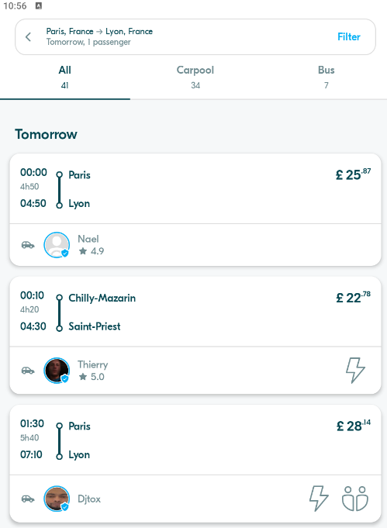

**Q1 –** What are the **different workflows** to **modify** my ride input (*i.e., change the date, departure etc.)*

* **Workflow 1 Change the Number of Passengers: Tap on the "Passengers" button > Modify the number of passengers > click on “Search” to processed.**
* **Workflow 2 Change the Destination**: **Tap on the "To" field on top of the screen > Modify the destination > click on “Search” to processed.**

**Q2 –** What are the **used UI components** and your **UX analysis** for each of bellow scenario: (see example)

|  |  |  |
| --- | --- | --- |
| SCENARIO | UI COMPONENT | UX ANALYSIS |
| Sort by (*Price, time etc.)* | Dropdown Menu or Sort Options (Price, Time) | Providing sorting options allows users to quickly view rides based on their preferences (e.g., cheapest or quickest). **(Efficiency & Use)** |
| Filter on the pickup time | Date/Time Picker | Using a date/time picker allows users to filter rides based on a specific time, making it easy to find rides that match their schedule. **(Clarity & Accuracy)** |
| Show only the BUS options | Toggle Switch or Checkbox | A **toggle switch** or **checkbox** makes it easy for users to see only bus options by turning the filter on or off. This keeps things **simple** and helps users find what they want **faster**. |
| Overview of available rides  important information | List/Grid View | A **list or grid view** makes it easy for users to scan and compare rides quickly by displaying key details like **price, time, and type (bus/car)** clearly  (Clarity & Information Availability) |

#### **VIEW 3** – Details on **BUS** Ride

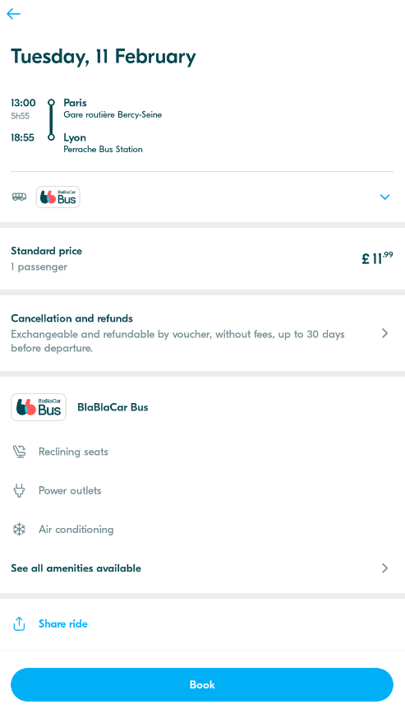

**Q1 –** What are the **used UI components** and your **UX analysis** for each of bellow scenario: (see example)

|  |  |  |
| --- | --- | --- |
| SCENARIO | UI COMPONENT | UX ANALYSIS |
| See the ride important information | Summary Card or Info Section | A summary card shows important details like departure time, price, and trip duration in an organized way. This helps users quickly find the information they need. **(Clarity & Accessibility)** |
| See Bus ride stops | Expandable List or Interactive Map | Users can view all bus stops in a structured list or interactively on a map.**( Efficiency & Predictability)** |
| Check conditions | Text/Link List | Displays cancellation policies, luggage rules, etc.  (System status or Error Prevention) |
| Share ride | Share Button with Social Media & Copy Link Options | A clear share button allows users to quickly send ride details to others via messaging apps, social media, or a copied link.( **Flexibility & Convenience)** |
| Book | Button (“Book Now”) | **Directs user attention** to the main action. users **understand what will** |

#### **VIEW 4** – Details on **CARSHARE** Ride

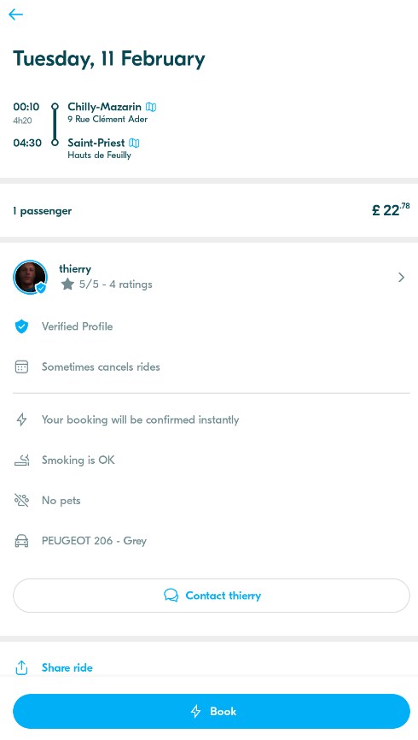

**Q1 –** What are the **used UI components** and your **UX analysis** for each of bellow scenario: (see example)

|  |  |  |
| --- | --- | --- |
| SCENARIO | UI COMPONENT | UX ANALYSIS |
| See the ride important information | Summary Card/Info Panel | A summary card or info panel shows key details like departure time, price, and car type clearly in one place. (Visibility of System Status) |
| See the meeting location | Map View/Location Pin | A map or location pin displays the meeting spot visually, helping users easily understand where to meet.( Match Between System and the Real World) |
| Check driver profile | Profile Card/Driver Info | A profile card or driver info section lets users view the driver's details, such as name, picture, rating, and vehicle information.( Trustworthiness and Credibility) |
| Contact the driver | Contact Button/Message Icon | A contact button or message icon enables users to reach out to the driver easily if they have questions or need to clarify something.( Flexibility and Efficiency of Use) |
| Book | Booking Button | A prominent and clear "Book" button allows users to confirm their ride choice. It should be easily accessible, with a color or design that makes it stand out(Visibility of System Status) |